**Evaluate and Communicate Biz Req**

Evaluate and Communicate Biz Req

**Devrin Hocellino**

Devrinho.2004@gmail.com

|  |  |  |  |
| --- | --- | --- | --- |
| Name of Student | Devrin Hocellino | ID | 18559 |

# Assessment –

# Research & Questioning

Contents

Assessment – 1

Research & Questioning 1

***Instructions:*** 1

***Business Scenario*** 1

***Task 1: Determine support areas*** 2

***Task 2: Identify stakeholders*** 3

***Task 3: Develop support procedures*** 4

***Task 4: Assign Support Personnel*** 6

***Task 5: Short Answer Questions*** 6

***Task 6: Multiple Choice Questions*** 7

Index 12

#### View My Web Support:

[ECBRby18559 (devrin-ho.github.io)](https://devrin-ho.github.io/ECBRby18559/)

#### *Instructions:*

This assessment is to be completed individually. In this assessment you will be working through a number of written tasks based on case scenarios or research that relate directly to each element of competency for this cluster. Outlined below is information on how each of the tasks relates the element of competency covered.

Learn how to make Google Form: <https://www.youtube.com/watch?v=BtoOHhA3aPQ&t=4s>

Your tasks:

#### *Business Scenario*

D&K Books Pty Ltd is a bookstore owned by Mr. Dean Kerr. The business occupies two levels of an office building connected by escalators and lifts. D&K Books employs approximately six sales staff, one operation manager, two administrative officers, a bookkeeper and a marketing manager. They have an Ethernet network consisting of ten PCs (Intel I3 Desktop cloned), two switches, a router and three printers. They use the QuickBooks software to manage their entire business, including sales, inventory, ordering, accounts receivable, accounts payable, payroll and employee management. They also have two EFTPOS terminals one on each floor.

D&K Books has a Linux server that stores all of the data including the QuickBooks database. The server is backed up to tape regularly. They also have a website (hosted on an Australian ISP’s server, dynamic and static pages using asp.net) on which customers can browse the product catalogue and view current specials. They also lease a telephone system from Live Telecoms. The PABX (phone system) consists of a main switchboard and five remote phones with three incoming lines and a message-on-hold queue system.

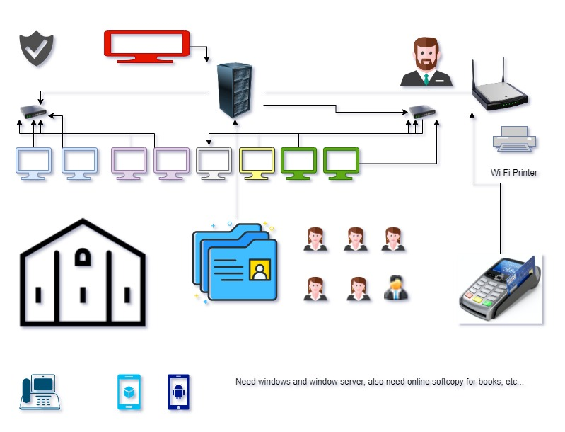

Good network system, you need setup at least:

|  |  |
| --- | --- |
| Hard ware | Software |
| Server X 1 | Window Server |
| Computers X 8 | Windows |
| WI-FI Printer X 1 | SQL server (now we could use Google Sheets) |
| Telephone and Mobile Device X 8 | Virus Protection |
| Router X 2 | MS office (now we could use the Google products) |
| POS System X 1 | POS Software |

#### *http://imapwebsolutions.com/wp-content/uploads/2014/07/linux-dedicated-server.pngTask 1: Determine support areas*

Identify information technology (HW and SW) and list the technology in use in D&K Books and consider the following:

* What sort of support does the technology require?
* Who is likely to provide this support?
* Does the support arrangement already exist?

Present your answer in a table such as the one below:

|  |  |  |  |  |
| --- | --- | --- | --- | --- |
| **Technology** | **Description** | **Support Required** | **Provider** | **Support Already exists? (Yes/No)** |
| QuickBooks Software | software that keeps track of all accounts, stock, GST, etc. | customisation, training, upgrades, bug fixes (patching), user support | [www.intuit.com.au](http://www.intuit.com.au)  online to find more | No |
| Desktop Computers | Used by staff for daily operation | Hardware maintenance, software updates, troubleshooting | IT team | No. Need find one person to do this job |
| Cloud Storage Server | Cloud-based storage solution for backing up important files and documents | |  | | --- | | Cloud service management, data backup, security |  |  | | --- | |  | | |  | | --- | | Google Drive |  |  | | --- | |  | | Yes |
| Point of Sale (POS) System | Easy to use processing sales transaction | Regular software updates, hardware, and troubleshooting | POS vendor or IT team | Yes |
| Email System | Communication with customers and suppliers | Email hosting, spam filtering, troubleshooting | Gmail | Yes |
| Website | Online platform for selling products | Website maintenance, security updates, and content management | IT team | Yes |
| Wi-Fi Network | Wireless network for internet access | Troubleshooting, and security updates | Internet Service Provider (ISP) | Yes |

Please review my website: [18559 Devrin (devrin-ho.github.io)](https://devrin-ho.github.io/ECBRby18559/#businesscase)

My web contact: https://devrin-ho.github.io/ECBRby18559/#businesscase

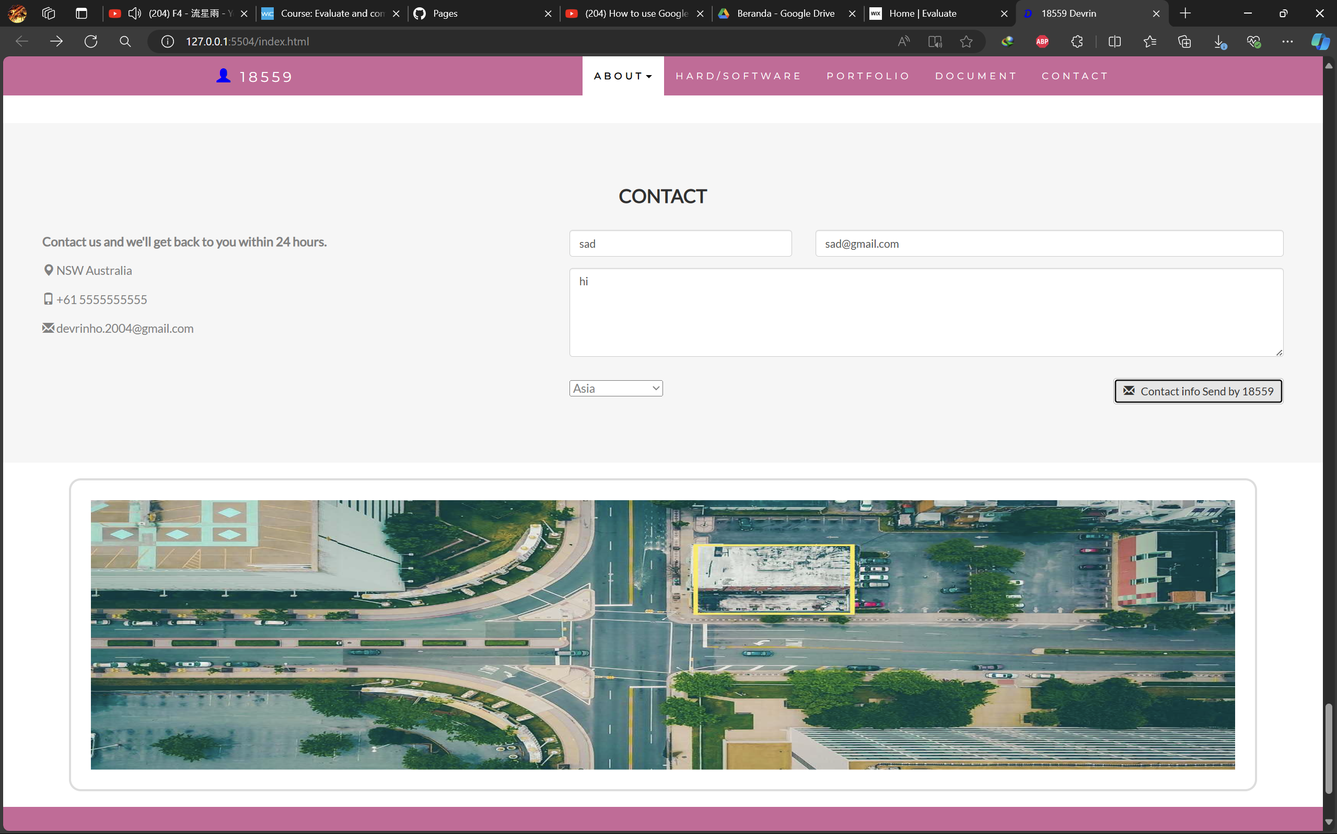

After your input, it will be recorded at:

You could be accessed by:

[ECBR by 18559 (Jawaban) - Google Spreadsheet](https://docs.google.com/spreadsheets/d/1YP5Gg7r5uznoqYk80hLWCJS2kF6mDfT6TrU6XAJvfo0/edit?gid=1080040388#gid=1080040388)

#### *Task 2: Identify stakeholders*

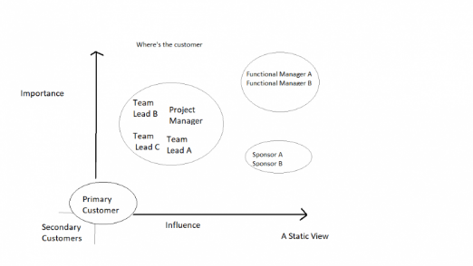Identify stakeholders related in D&K Books system

All the staffs (the business owner, the relevant manager, the local workers and the remote workers) are stakeholders

the placement of each stakeholder should reflect their role within D&K Books’ system.

#### *Task 3: Develop support procedures*

1. Describe one positive and one negative experience you have had when seeking assistance from a telecommunication company, an ISP or a computer supplier. Your experience may be via telephone, email or even voice recognition.

|  |  |  |
| --- | --- | --- |
| Type | Positive | Negative |
| Telephone | Easy to get answer | Document provide |
| Email | Document, Picture, words or any media | Have to wait |
| Go to company | Face to face get answer | Cost time and money on trip |
| Message | Easy step by step instructions | Have to wait |

1. Using the experiences described above please answer the following questions.
   1. What support aspects were professional and/or unprofessional?
   2. How long did the support process take?
   3. Were the steps logical?
   4. Did they solve your problem?
   5. Was the call deflected to another area?

|  |  |  |
| --- | --- | --- |
| Items | professional | unprofessional |
| What support aspects | Friendly, Listening | Not what know your customer |
| How long | Very quick | Waiting and waiting |
| Steps logical | Yes | No |
| Solve | Good | Can not |
| Another area | If has, need solve | If has, do not care |

Using feedback form or Google survey form.

Here is the very simple survey demo:

After I tested my friends, I could get nice response like:

Or using link string:

[ECBR by 18559 (Jawaban) - Google Spreadsheet](https://docs.google.com/spreadsheets/d/1YP5Gg7r5uznoqYk80hLWCJS2kF6mDfT6TrU6XAJvfo0/edit?resourcekey=&gid=1080040388#gid=1080040388)

Please review my website: [18559 Devrin (devrin-ho.github.io)](https://devrin-ho.github.io/ECBRby18559/#taskthree)

#### *Task 4: Assign Support Personnel*

Classify the following into soft skills and technical skills. Your answer should take the form of a table shown below.

|  |  |  |
| --- | --- | --- |
| **Skill** | **Soft skill** | **Technical skill** |
| A knowledge of Linux | X |  |
| The ability to work under pressure | X |  |
| The administration of Windows 2008 Server |  | X |
| The ability to formulate network and IT policies |  | X |
| The ability to write network documentation |  | X |
| The ability to give presentations | X |  |

#### *Task 5: Short Answer Questions*

1. 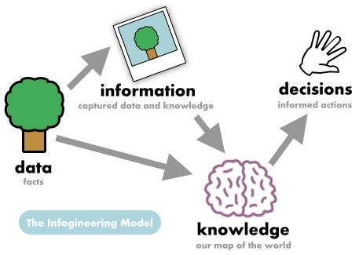Explain the relationship between data, information and knowledge.

To make decisions, we need to have knowledge to understand information from the data and context we got

1. What is quantitative data and how can you use it.

Numerical data that can be counted or measured. Often represented numbers, quantities, and values, suitable for statistical analysis

1. What is qualitative data and how can you use it.

Descriptive data based on observations and non-numerical attributes. And is useful for understanding the underlying reasons, motivations, and perceptions behind certain behaviours or trends

1. 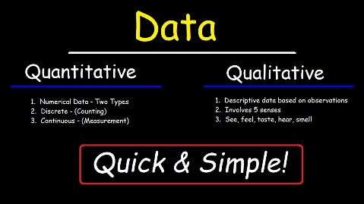Give an example of how quantitative and qualitative data can be used in conjunction with each other

By combining the quantitative data with the qualitative data, the company can gain a more comprehensive understanding of customer satisfaction.

1. What sort of methods could you use to determine client requirements for a website design and key information sources?

Create a web design client checklist

1. Give some examples of client requirements for a website design

* Looks good
* 24 hours work
* Easy to update
* Upgrade is free

#### *Task 6: Multiple Choice Questions*

1. 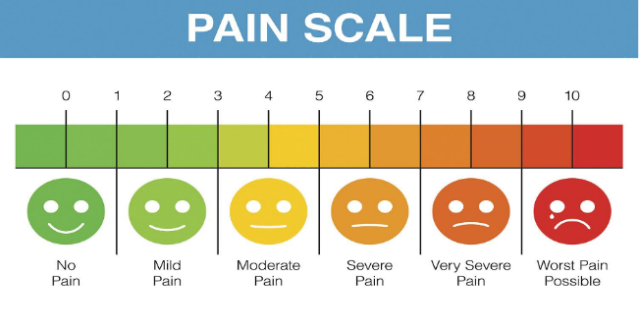Generally, how many points should a rating scale have?
   1. Five
   2. Four
   3. Ten
   4. Somewhere from 4 to 11 points

Reason

Web refer: <https://lumoa.me/blog/rating-scale>

A rating scale is a closed-end survey question that is used to evaluate how survey responders feel about a particular product or statement.

Comment: I like 10 points. It is easy and clear to get the best feedback way.

1. What is the problem(s) with this set of response categories to the question “What is your current age?”

* 1-5
* 5-10
* 10-20
* 20-30
* 30-40
  1. The categories are not mutually exclusive
  2. The categories are not exhaustive
  3. Both a and b are problems
  4. There is no problem with the above set of response categories

Reason - The age categories are not mutually exclusive (e.g., someone who is exactly 5 years old is included in both the "1-5" and "5-10" categories) and they are not exhaustive (there is no category for ages beyond 40).

1. You should mix methods in a way that provides complementary strengths and no overlapping weaknesses. This is known as the fundamental principle of mixed research.
   1. True
   2. False

Reason - The principle of mixing methods involves leveraging the strengths of different approaches while minimizing their respective weaknesses.

1. According to the text, questionnaires can address events and characteristics taking place when?
   1. In the past (retrospective questions)
   2. In the present (current time questions)
   3. In the future (prospective questions)
   4. All of the above

Reason - Questionnaires can be used to gather data about past, present, and future events and characteristics.

1. Which of the following are principles of questionnaire construction?
   1. Consider using multiple methods when measuring abstract constructs
   2. Use multiple items to measure abstract constructs
   3. Avoid double-barrelled questions
   4. All of the above
   5. Only b and c

Reason - Effective questionnaire construction involves using multiple methods to measure abstract constructs, using multiple items to measure those constructs, and avoiding double-barrelled questions.

1. Which of these is not a method of data collection?
   1. Questionnaires
   2. Interviews
   3. Experiments
   4. Observations

Reason­ - Experiments are a research design rather than a direct method of data collection. The methods of data collection include questionnaires, interviews, and observations.

1. Secondary/existing data may include which of the following?
   1. Official documents
   2. Personal documents
   3. Archived research data
   4. All of the above

Reason - Secondary data can include official documents, personal documents, and archived research data.

1. An item that directs participants to different follow-up questions depending on their response is called a ____________.
   1. Response set
   2. Probe
   3. Semantic differential
   4. Contingency question

Reason - A contingency question directs respondents to different follow-up questions based on their previous answers.

1. Which of the following terms best describes data that were originally collected at an earlier time by a different person for a different purpose?
   1. Primary data
   2. Secondary data
   3. Experimental data
   4. Field notes

Reason - Secondary data refers to data collected by someone else for a different purpose than the current research.

1. Researchers use both open-ended and closed-ended questions to collect data. Which of the following statements is true?
   1. Open-ended questions directly provide quantitative data based on the researcher’s predetermined response categories
   2. Closed-ended questions provide quantitative data in the participant’s own words
   3. Open-ended questions provide qualitative data in the participant’s own words
   4. Closed-ended questions directly provide qualitative data in the participants’ own words

Reason - Open-ended questions allow participants to provide responses in their own words, resulting in qualitative data.

1. Open-ended questions provide primarily ______ data.
   1. Confirmatory data
   2. Qualitative data
   3. Predictive data
   4. None of the above

Reason - Open-ended questions typically yield qualitative data, which is rich and detailed.

1. Which of the following is true concerning observation?
   1. It takes less time than self-report approaches
   2. It costs less money than self-report approaches
   3. It is often not possible to determine exactly why the people behave as they do
   4. All of the above

Reason - Observation may not reveal the underlying reasons for behavior, unlike self-report methods.

1. Qualitative observation is usually done for exploratory purposes; it is also called ___________ observation.
   1. Structured
   2. Naturalistic
   3. Complete
   4. Probed

Reason - Naturalistic observation is used for exploratory purposes and involves observing subjects in their natural environment.

1. When constructing a questionnaire, it is important to do each of the following except ______.
   1. Use "leading" or "loaded" questions
   2. Use natural language
   3. Understand your research participants
   4. Pilot your test questionnaire

Reason - Leading or loaded questions should be avoided as they can bias responses.

1. Another name for a Likert Scale is a(n):
   1. Interview protocol
   2. Event sampling
   3. Summated rating scale
   4. Ranking

Reason - A Likert Scale is also known as a summated rating scale because it involves summing responses across a series of items.

1. Which of the following is not one of the six major methods of data collection that are used by educational researchers?
   1. Observation
   2. Interviews
   3. Questionnaires
   4. Checklists

Reason - Checklists are not typically listed as a major method of data collection in educational research, unlike observation, interviews, and questionnaires.

1. The type of interview in which the specific topics are decided in advance but the sequence and wording can be modified during the interview is called:
   1. The interview guide approach
   2. The informal conversational interview
   3. A closed quantitative interview
   4. The standardized open-ended interview

Reason - The interview guide approach involves having predetermined topics but allows flexibility in how questions are asked.

1. Which one of the following in not a major method of data collection:
   1. Questionnaires
   2. Interviews
   3. Secondary data
   4. Focus groups
   5. All of the above are methods of data collection

Reason - Secondary data refers to previously collected data rather than a method of data collection itself.

1. A question during an interview such as “Why do you feel that way?” is known as a:
   1. Probe
   2. Filter question
   3. Response
   4. Pilot

Reason - Probes are used to elicit more detailed responses from participants.

1. A census taker often collects data through which of the following?
   1. Standardized tests
   2. Interviews
   3. Secondary data
   4. Observations

Reason - Census data is commonly collected through interviews or surveys.

1. The researcher has secretly placed him or herself (as a member) in the group that is being studied. This researcher may be which of the following?
   1. A complete participant
   2. An observer-as-participant
   3. A participant-as-observer
   4. None of the above

Reason - A complete participant is one who is fully immersed in the group they are studying without revealing their research role.

1. Which of the following is not a major method of data collection?
   1. Questionnaires
   2. Focus groups
   3. Correlational method
   4. Secondary data

Reason - The correlational method is a research design rather than a direct method of data collection.

1. Which type of interview allows the questions to emerge from the immediate context or course of things?
   1. Interview guide approach
   2. Informal conversational interview
   3. Closed quantitative interview
   4. Standardized open-ended interview

Reason - Informal conversational interviews allow questions to evolve based on the conversation.

1. When conducting an interview, asking "Anything else?, What do you mean?, Why do you feel that way?," etc, are all forms of:
   1. Contingency questions
   2. Probes
   3. Protocols
   4. Response categories

Reason - Probes are used to encourage further elaboration and clarification in responses.

1. When constructing a questionnaire, there are 15 principles to which you should adhere. Which of the following is not one of those principles?
   1. Do not use "leading" or "loaded" questions
   2. Avoid double-barrelled questions
   3. Avoid double negatives
   4. Avoid using multiple items to measure a single construct

Reason - Using multiple items to measure a single construct is a common principle to ensure reliability and validity.

1. A customer-based Service Level Agreement structure includes:
   1. An SLA covering all Customer groups and all the services they use
   2. SLAs for each service that are Customer-focused and written in business language
   3. An SLA for each service type, covering all those Customer groups that use that Service
   4. An SLA with each individual Customer group, covering all of the services they use

Reason - A customer-based SLA structure focuses on each service in terms of customer needs and is presented in business language.

1. Which of the following best describes the goal of Service Level Management?
   1. To maintain and improve IT service quality in line with business requirements
   2. 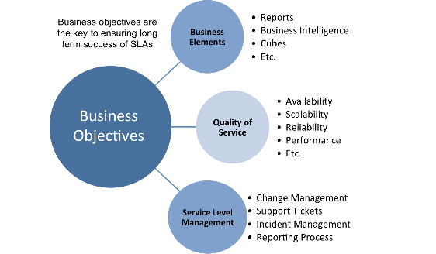To provide IT services at the lowest possible cost by agreeing with Customers their minimum requirements for service availability and ensuring performance does not exceed these targets
   3. To provide the highest possible level of service to Customers and continuously improve on this through ensuring all services operate at maximum availability
   4. To ensure that IT delivers the same standard of service at the least cost

Reason - The goal of Service Level Management is to ensure IT services meet business needs and improve over time.

1. The process to implement SLAs comprises of the following activities in sequence:
   1. Draft SLAs, catalogue services, review underpinning contracts and OLAs, draft SLRs, negotiate, agree SLAs
   2. Draft SLAs, review underpinning contracts and OLAs, negotiate, catalogue services,
   3. Review underpinning contracts and OLAs, draft SLAs, catalogue services, negotiate, agree SLAs
   4. Catalogue services, establish SLRs, review underpinning contracts and OLAs, negotiate service levels, agree SLAs

Reason - This sequence ensures that SLAs are developed and agreed upon systematically.

1. Which of the following is an example of a service level agreement (SLA) between information systems support unit and a research unit in the laboratories of a large company?
   1. The maximum response time to get the system operational should it fail.
   2. The minimum ‘up-time’.
   3. The types of information that will be provided as standard.
   4. All of the above.

Reason - All these examples are components that could be part of an SLA, detailing response times, uptime, and standard information types.

1. Some organisations bring a degree of formality to the internal customer concept by encouraging (or requiring) different parts of the operation to agree on:
   1. Internal service agreements
   2. Service level agreements
   3. Formal provision agreements
   4. Delivery agreements

Reason - Internal service agreements formalize the expectations and responsibilities between different parts of an organization.

## Index

B

bookstore 1

C

categories 6

closed-ended 7

D

data collection 9

L

Linux server 2

N

network 1

O

open-ended 7

S

Service Level 9

service level agreement 10

service quality 10

soft skills 5

support 3

T

technology 2

telecommunications 3